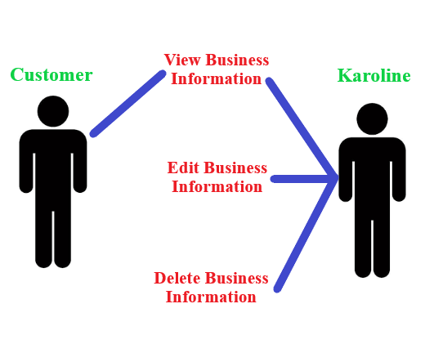

Business Information Diagram

The above diagram illustrates the interactions between a customer and Karoline when engaging in multiple use cases involving business information on the website. It is to be concluded that any customer and/or Karoline may view existing business information, but only Karoline can edit or delete existing business information.